ANALYSIS
For the analysis of consumer, u-home conducted two surveys, one for people who are looking for a room and the other for those who want to publish one for them. These were the questions we did for who search a room put them in a way that let us analyze that it is the main thing they seek when choosing it and the results that we got.

Students mainly looking for a place to live in the capital of colombia, Bogotá, students interviewed a 60.4% prefer to live in a place and a 35.4% would be willing to live in a student residence in the same way any you would like to live in a room for convenience it is preferably live in an apartment and how serious only temporarily a House would be great for them. I ask if they would like to a place owned or leased and 87.5% prefer own place. According to his economic situation when it comes to finding a place to live are students willing to pay between 500,000 to 750,000 COP and prefer that payment is monthly, another essential feature for them is the time that would be willing to take on the way from home to the place of study a 47.9% you like entity 20 and 30 minutes whereas a 33.3% you would like between 10 and 20 minutes.
Also ask that kind of people you would like to live and answers we had a result equal between living alone and live with people from the same University, in the same way when choosing their place of dwelling 47.9% looking for a place with close proximity to shopping malls and a 33.3% prefer in University areas. Finally we asked students how time would remain in place of housing which found that 68.8% respond to one year.

In conclusion, many students today on day seek comfort and benefits that the place of dwelling, as we can see many prefer to live close to malls close to sports sites and similarly also take their decision to close this place of study, since they come from another city. Given their economic condition would be willing to pay a good price for a lease of its housing with services included and this would be monthly.

En cual de las siguientes ciudades te gustaría vivir mientras estudias?
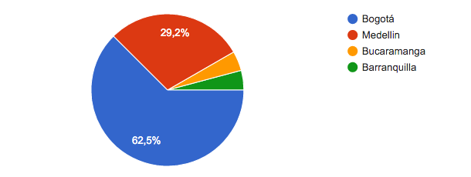

Donde te gustaría vivir mientras estas en la Universidad?
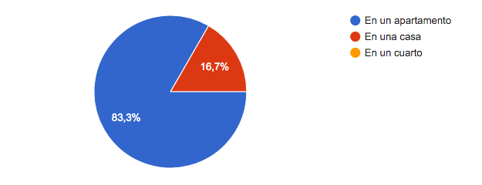

Mientras estudias en la Universidad, te gustaría vivir en un lugar:
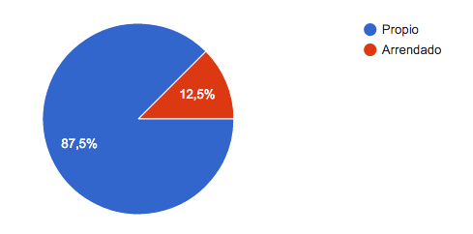

Siendo usted estudiante en otra ciudad, estaría dispuesto a vivir en:
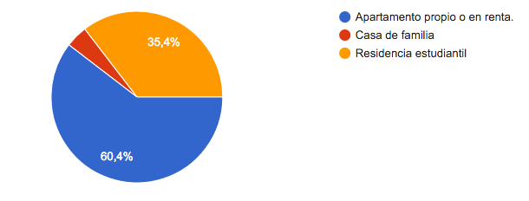

Teniendo en cuenta su situación, cual seria su promedio de renta mensual a pagar?
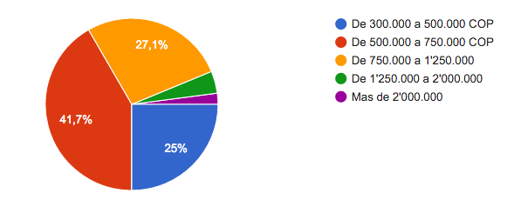

Como preferiría que fuera el método de pago?
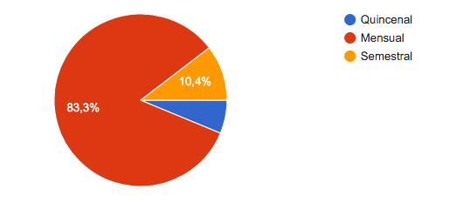

Cuanto tiempo estarías dispuesto a tardar por trayecto desde tu casa hasta el lugar de estudio?

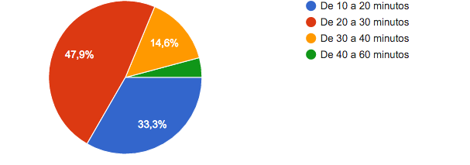

Con que clase de personas te gustaría vivir?

Que tipo de sitios de interés influencia su decisión a la hora de escoger su lugar de vivienda?
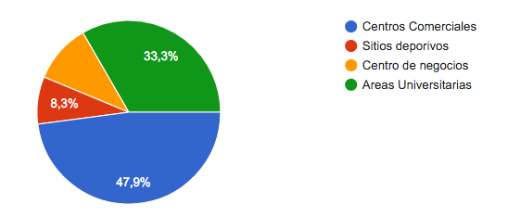

Por cuanto tiempo desearía permanecer en un lugar de vivienda?
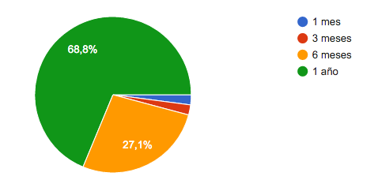

In the case of people who want to publish, we performed 10 questions, which seek to know what proportion of people willing to rent, to what type of people, how much to charge, the types of properties that are available, among others. Of the total people polled, 72.4% are willing to establish such an agreement is lease or sale to college students. As for the decision to use an intermediary to establish the agreement, 48.3% prefer to make arrangements directly.
But at the time of publication on the internet of supply, respondents are willing to pay between 40,000 and 50,000 per publication.
It could also found that the vast payoria with 27.6% have properties of layer 4 and none is in strata 1 and 2.
As for gender preference with whom to do the deal, the majority of respondents are indifferent to whether it is male or female, but there is a preference to almost double over women. The type most common in this type of agreement is the lease of a room, and in which those who are interested in publishing, most usually only 1 room available.
It is necessary to establish the amount of money charged to allow this agreement to be profitable, and from this we conclude that the vast majority with 34.5% willing to charge between $ 500,000 to $ 700,000 Colombian pesos.
As for the duration of the agreement, most of the bidders 39.3%, looking to make agreements with duration of 1 semester and followed with 17.9% for 3 months. It states that one of the main advantages that bidders must have is that the property is located somewhere near the public transport system of the city, which is the case of 58.6% of the sample. On the same way, 31% prefer tenants with an age range between 20 and 25 years, followed by 14% who prefer peronas between 17 and 20 years. Is necessary to determine it was discovered that most of the bidders are not usually college students, because they occupy a wide range in the sample of the population, this could be established by the high number of responses of the "No Aplica"

